Chapter 17, Problem 41.

The full-wave rectified sinusoidal voltage in Fig. 17.77(a) is applied to the lowpass filter in Fig. 17.77(b). Obtain the output voltage v_{o}(t) of the filter.

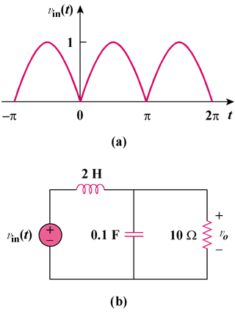

Figure 17.77
For Prob. 17.41.

